Leveraging larger markets to encourage innovation in prosthetics: Design of myopen, an open myoelectric signal processor for use as an input device for video gaming and hobby robotics
Timothy Hanson and Jonathan Kuniholm
Duke University and The Open Prosthetics Project
Abstract
The prosthetic arm market is small; perhaps 70,000 people lack arms in the US. This, coupled with the difficulty of making and controlling a mechatronic hand replacement, has forestalled innovation in arm prostheses in the fifty years since its introduction. Since the Boston Arm project in 1965, the popular press has promised thought-controlled prosthetic arms, yet the promises of scientific research have not often been kept in the clinic. We aim to surmount these obstacles by developing an open myoelectric signal processor targeted at researchers, hobbyists, and video game enthusiasts. Our device is capable of processing 16 channels of surface electromyographic (EMG) (or other data), applying pattern recognition algorithms in real-time via a power-efficient Blackfin DSP, and delivering the results through ethernet, I2C, RS232, USB, and Lego NXT bus. We hope that this open, commodity level platform will become a disruptive technology, encouraging experimentation in the algorithms and applications of a field that has been sequestered too long in the research lab.

BACKGROUND
Much recent media attention about prosthetic arms has surrounded the Defense Advanced Projects Administration (DARPA) Revolutionizing Prosthetics Program (RP2007/2009) and military amputees from recent conflicts. There remains a disconnect between the reality facing an arm amputee and this coverage in the popular press. As of 2007, there were fewer than 700 US military amputees from Iraq and Afghanistan, of whom fewer than 150 were arm amputees. Despite the relatively small numbers involved, the media coverage may have contributed to a welcome increase in efforts to improve arm technology. The DARPA prosthetic program has been compared to the Manhattan Project and the race to put a man on the moon. While perhaps an apt comparison in terms of the technical challenges presenting the researchers, the comparison of project budgets in Figure 1 shows that the Revolutionizing Prosthetics Program budgets represents a small fraction of the size of those of the two historical projects. The massive historical efforts in fact compare in size to the R & D costs alone of the current F-35 Joint Strike Fighter program.
The deficiency that these programs seek to correct is a basic lack of widely adopted advanced upper extremity products. Many amputees, despite being fitted with myoelectrics, return to body powered designs that have changed little in fifty years. Powered products remain slower, heavier, more fragile and more uncomfortable than the alternatives. This is no fault of the companies that serve arm amputees, but the result of a convergence of factors: the small market size, and the difficulties of the problem of replacing an arm. It is not clear that these realities will make the transition of the impressive technology developed by the RP2007/2009 teams to commercial products any easier. It is this “last mile” of the transfer of technology that we have sought to address with this project.
Figure 1: Project Budgets (Billions of 2006 Dollars)
What is it that separates mass markets from underserved ones? It is the distribution and therefore lowering of costs, in research and development, manufacturing and distribution to a large number of users. It is also the commodification of products in the marketplace, reducing profit margins because of the availability of alternatives. As illustrated in Figure 2, the buying power in the current market for powered arms cannot hope to challenge that for razors and blades. The ability of these larger markets to overcome higher fixed cost barriers to entry explain the pace of innovation in those areas.
Figure 2: Recent Annual Sales ($Billions)
PARASITIZING A LARGER MARKET TO LEVERAGE TECHNOLOGY
Pattern Recognition
While other avenues exist for overcoming these barriers, the one that we have chosen is to seek application in markets with fewer limitations in buying power for underused technology in which we are interested. One of the most promising possibilities for prosthetic arm control is myoelectric pattern recognition. Despite more than 20 years of research in this area, and the advent of prosthetic hands with kinematic capabilities exceeding conventional control, no commercial product in arm prosthetics uses it. In order to help make this or any other advanced signal processing technology more accessible to amputee users (and manufacturer and prosthetist users), we have created a product that makes it possible to use pattern recognition or any other signal processing algorithm on skin surface EMG signals for a variety of applications.
In support of the project, a Matlab code base has been generously provided by Dr. Kevin Englehart at the University of New Brunswick (UNB), in Fredericton, Canada. The software, named CEVEN, contains code written by Dr. Englehart and his students, and was assembled into a single package by Blair Lock. This package provides training, classification of EMG signals through a variety of methods, and visual simulation of arm movements that can be paired with pattern recognition. UNB provides no support for the software, and all support and discussion should be maintained through the Google Code site: http://code.google.com/p/myopen/. Ultimately, the projects seeks to port the code to a python or similar high level and free platform, but the Matlab version is all that is currently available.
Using the Power of the Video Game Market
Of the collection of large mass markets shown in Figure 2, that for video games and game hardware is the largest. Worldwide spending is almost $18 billion on items for this type of entertainment. The industry has recently undergone several transformations in human interface, from the use of wireless and accelerometer technology in the Wii controller, to the Emotiv controller's use of EEG signals for “brain control.” Pattern recognition is an obvious very capable addition to the battery of ways in which humans can intuitively interact with a virtual world.
Openness Ensures Access to Technology
To ensure that all stakeholders can actually take advantage of the benefits that come from the use of pattern recognition in the video game market, we have chosen to release both our hardware and software designs under the open source GNU Public License. By ensuring that the designs will always be freely available and changeable, we can break down the silos that separate different uses for the technology, allowing user customization for purposes that we have not yet envisioned.
This approach has been around for a while in software, but is relatively new in hardware. Several current devices use it, including the Neuros OSD video device, and the Buglabs BUG. The multi-purpose linux BUG device with swappable and easily configurable components includes a GPS, touch screen and motion sensor, with which users can make their own embedded devices. Because of the added complexities involved in dealing with the physical world, this approach is still very much an experiment, and is really in its infancy.
TECHNICAL DETAILS
Our first iteration of the our open EMG signal processor, which we have called MyOpen, is a development board that is based on a Blackfin digital signal processor (DSP), a chip used in cameras and guitar pickups, for example. This board is capable of processing 16 channels of EMG, and has a variety of communications ports, including ethernet, I2C, RS232, USB, and Lego NXT bus. Figure 3 shows the populated board.
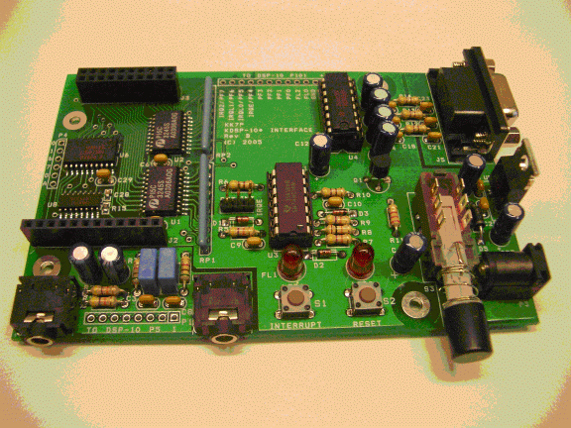Figure 3: The MyOpen EMG Digital Signal Processor

References
1. The text size for references may be reduced to 10 points.
2. List and number all references at the end of the paper. When referring to them in the text, type the corresponding reference number in square brackets.
3. The format for references is illustrated below:

1. van Heuningen, R., Goovaerts, H.G. & de Vries, F.R., "A low noise isolated amplifier system for electrophysiological measurements", Med. & Biol. Eng. & Comp., 22, 77-85, 1984.

